WORKSHEET 8

Student Name: Vivek Kumar UID: 21BCS8129

DOMAIN CAMP: 16-01-2023 to 28-01-2023 Section/Group: DWWC-77

Subject Name: IT Skills (DSA)

Question 1. KEYS AND ROOMS (DIVIDE AND CONQUER)

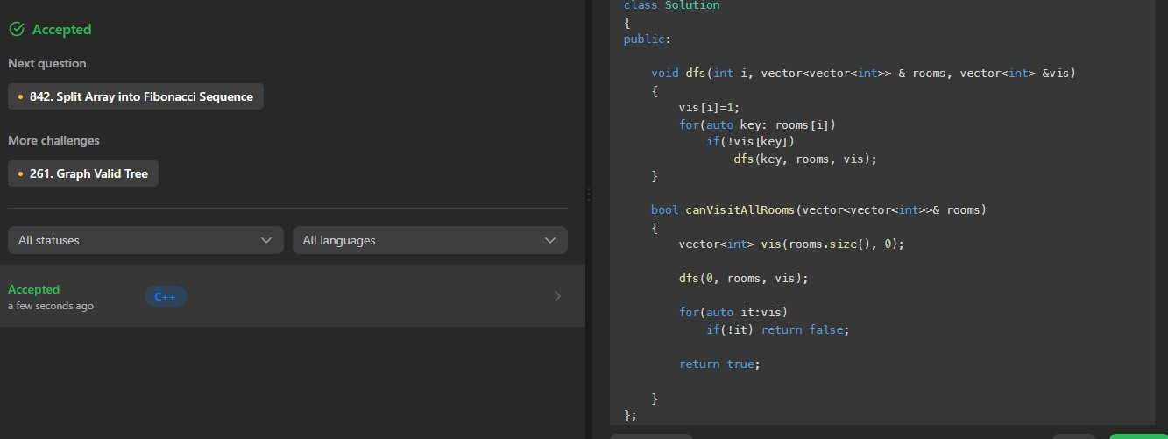

Question 2. DIVIDE ARRAY IN SETS OF K CONSECUTIVE NUMBERS (DIVIDE AND CONQUER)

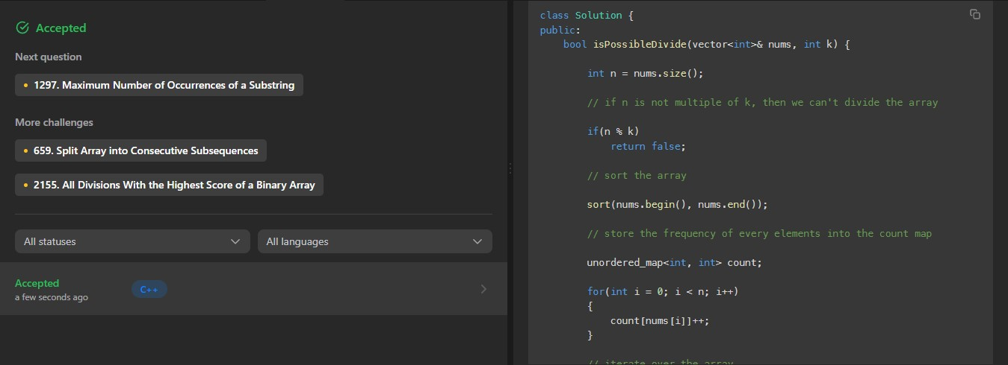

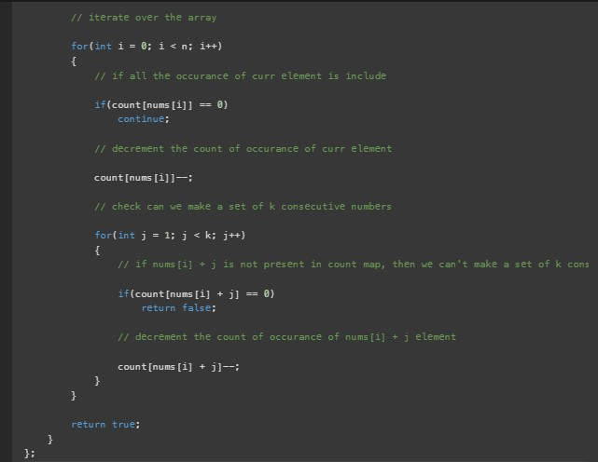

Question 3. FILTER RESTAURANTS BY VEGAN-FRIENDLY, PRICE AND DISTANCE (DIVIDE AND CONQUER)

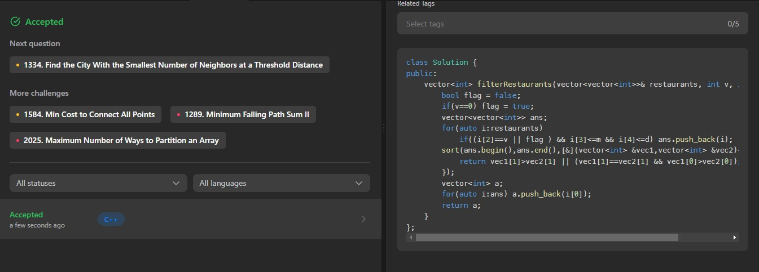

4 LONGEST PALINDROME BY CONCATENATING TWO LETTER WORDS (DIVIDE AND CONQUER)

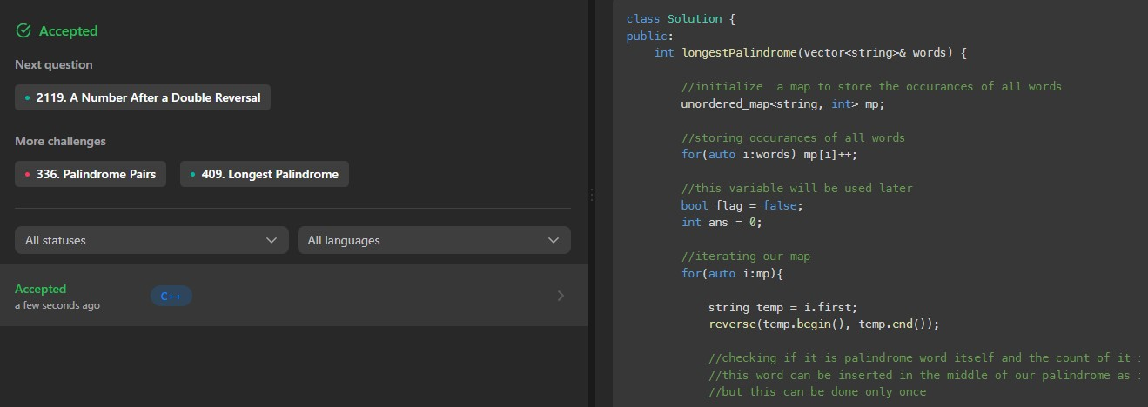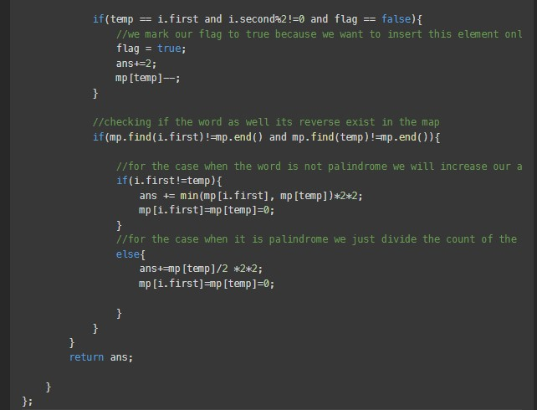

Question 5. BOOKING CONCERT TICKETS IN GROUPS (DIVIDE AND CONQUER)

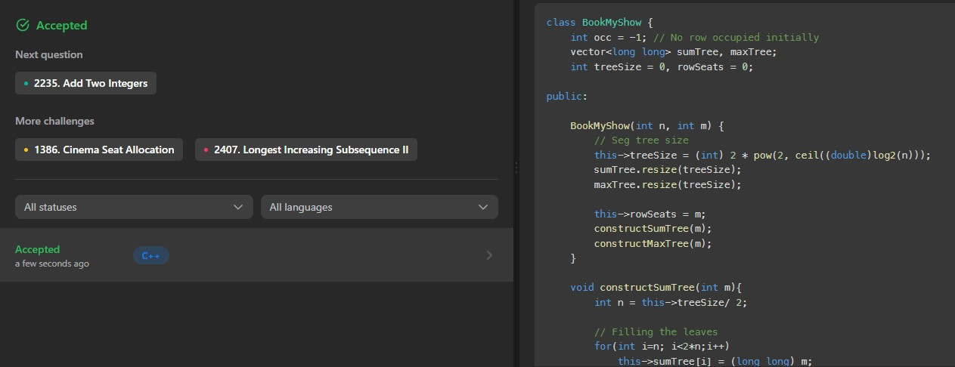

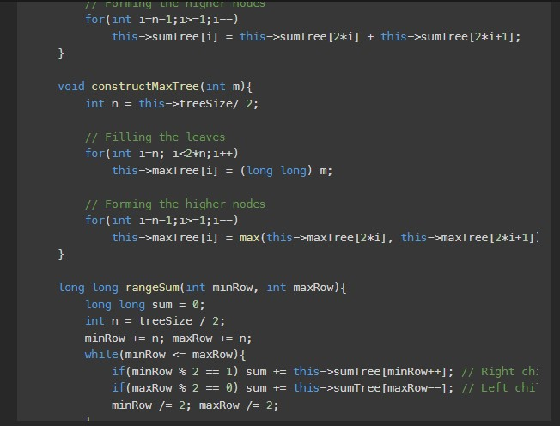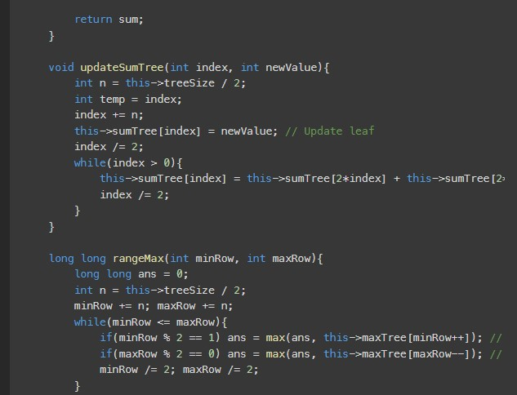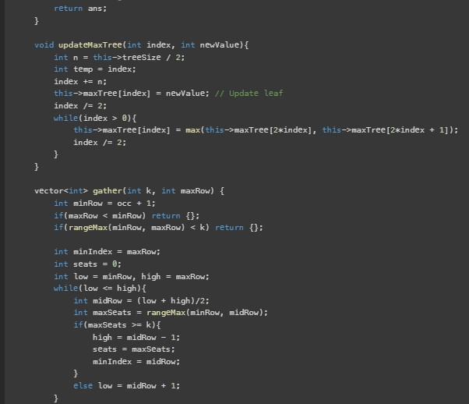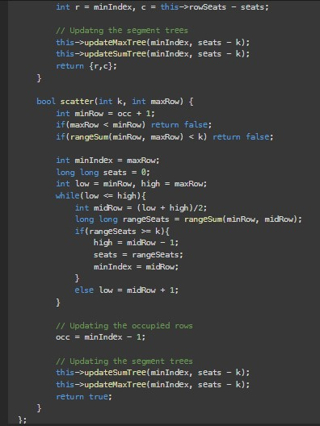

# **CANDY** (GREEDY APPROACH)

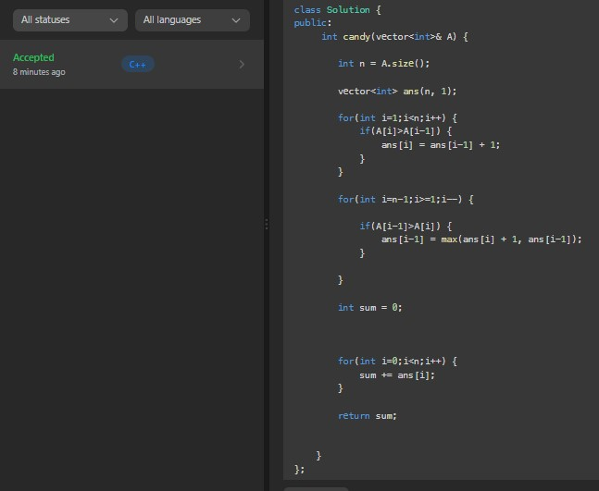

Question 7. REMOVE DUPLICATE LETTERS (GREEDY APPROACH)

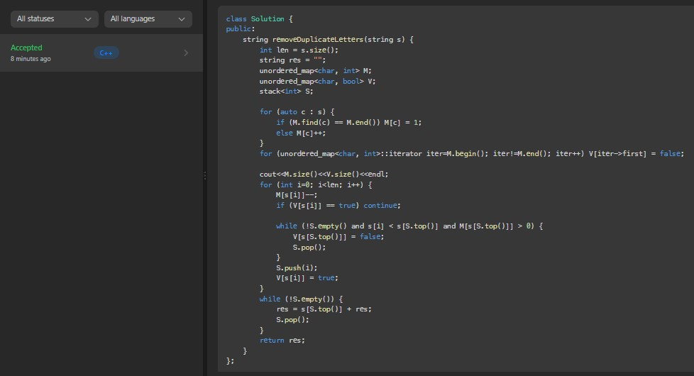

Question 8. AVOID FLOOD IN THE CITY (GREEDY APPROACH)

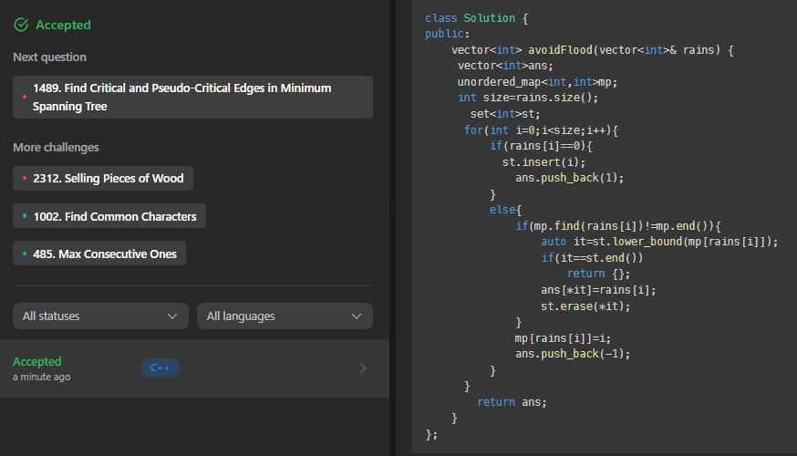

Question 9. CINEMA SEAT ALLOCATION (GREEDY APPROACH)

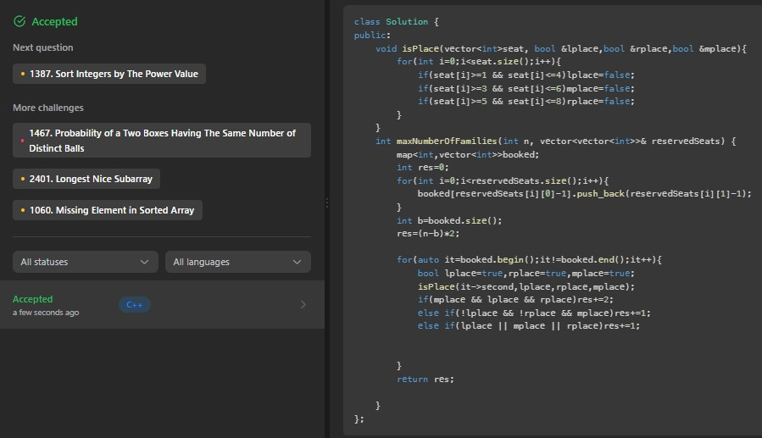

10 RABBITS IN FOREST (GREEDY APPROACH)

